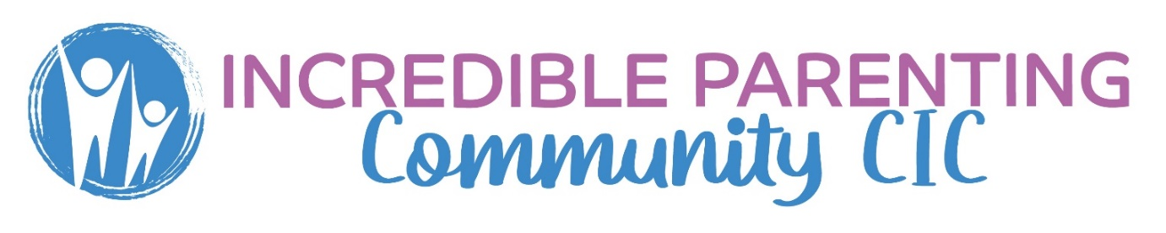
I would like to secure a place on:
Incredible Years (School Age) Parenting programme April 2024
STOP April 2024
Date
Name of parent:
Address:
Name of child/YP
DOB of child/YP
School attending/Yr group
Reason I would like to attend the course:

Hope to achieve from attending the course:

Does your child have a diagnosis or additional needs?

Thank you for taking the time to complete this form.
We look forward to speak with you soon


